Import Window
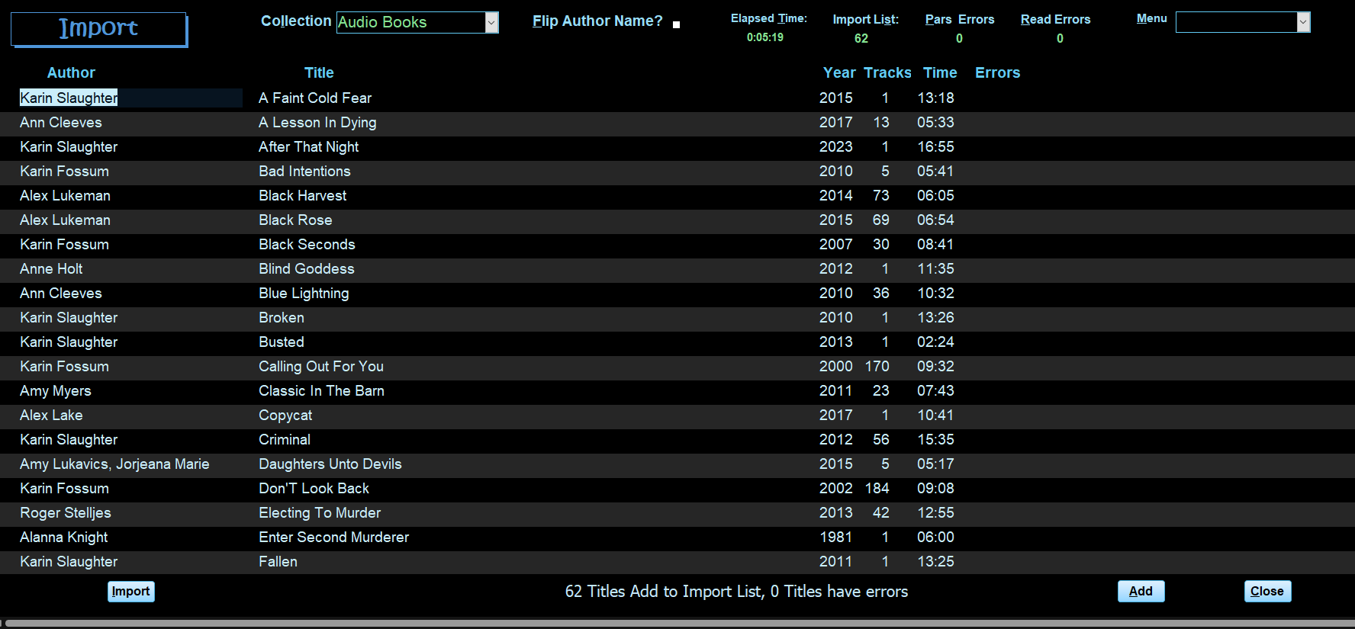

Import Window Header
The Header has the following controls left to right.
- Collection (alt-l) combo choose a collection. If only one collection exists in the database. It will default to that collection. If more than one Collection exists, then choose a collection from the combo box. Pressing Control+enter or double-clicking will open the Collection Window.
- Flip Author Name (alt-f) Check box flips the author’s name to last, first, default is unchecked.
- Elapsed Time: alt-t time the import took to complete hh:mm.
- Import List: alt-s number of records without errors.
- Parse Errors: alt-p, number of records that have errors, e.g., no author, etc.
- Read Errors: alt-r number of records, caused by corrupted file.

Import Window detail
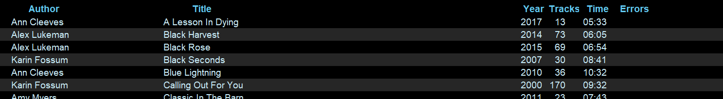
A continuous list with the following fields.
Author, Title, Year, Tracks, Time, Errors. All are plain text boxes.
Pressing Space Bar on a title will toggle the book from add to errors or vice versa.
Pressing F8 or double-clicking on a title with errors will open a detail Window that displays all data. This Window allows you to view/edit the item with errors.

Import Window Footer
Five buttons as follows:
- Import alt-I or F9 – Prompts for a folder to scan. All subfolders are scanned for tags. The prompt is a normal windows explorer dialog box. Select folder and click OK.
- Export alt-x – Exports a list of errors to a standard spreadsheet file.
- View alt-v – Open a detailed view of the book with errors, or F8 when cursor is in the title field.
- Add alt-a - Add the records without errors to the database.
- Close alt-c or F4 - close the Import Window. If there are no Audio Books in the database, the application closes. If Audio Books do exist, the Audio Book window will open.

Import Detail Window
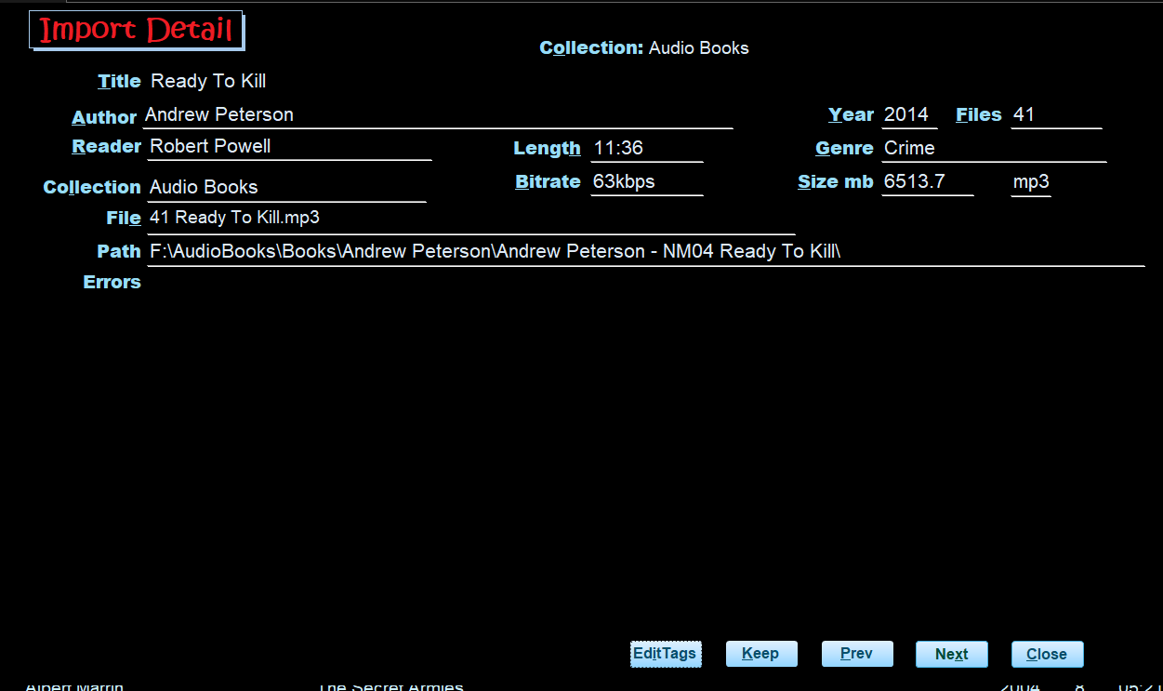
The data in this window is fully editable thus can be changed with no edits.

import Detail Error Header
Current Collection

import Detail Error Detail
Single Window with fields laid out in seven rows and three columns all fields are text boxs.
- Row1 - title alt-t
- Row2 -Author alt-a
  - Year alt-y - year the book was published.
  - Files alt-f - number of files
- Row3 - Reader alt-r
  - Time alt-m hour and minutes
  - Genre alt-g
- Row4 - Collection alt-l
  - Bitrate alt-b
  - Size alt-s – in MB
  - File Format – Mp3, etc.
- Row5 - Path alt-h - The location of the audio files. F8 or double-click to open the path in Windows File Explorer
- Row8 - Errors alt-o – List of the audio files and related errors. See Import Errors Description table below.

import Detail Error Footer
There are five buttons located at the bottom.
- Edit Tag – alt-I –open the Audio Book in a tag editor. This button is only visible if Mp3Tag or Tag Scanner is installed on your PC.
- Keep – clears the error flag and moves to the next record with errors.
- Prev alt-p, Next alt-n, or page-up and Page-down move between error records
- Close alt-c or F4 returns to the Import Window.

Importing:
From the Import Window:
- Click the Import button or press F9 or alt-I to start the import. (If any books exist on the import list you will be prompted to ask if you want to keep them. Click Keep alt-k or Delete alt-d .)
  - 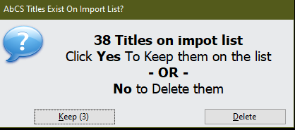
- Select the folder you want to scan and click OK.
- All controls on the window are locked during the import process. If there are many files being scanned a windows Shell Window may appear and it will go away on its own.
- The Importing Status window will display.
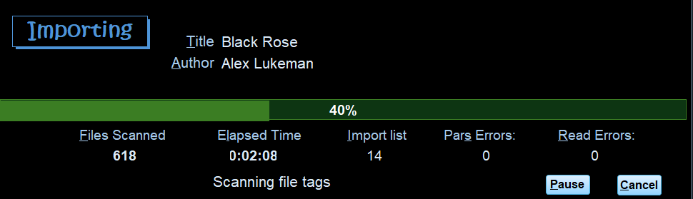
This window displays import progress and counts.
  - Title: alt-t and Author alt-a the current book being processed
  - Error alt-e – only display if the current book has an error.
  - Files Scanned alf-f the number of audio files scanned.
  - Elapsed Time alt-t
  - Import List alt-s – number of books added to the Import list.
  - Parse Errors: alt-p, number of records that have errors, e.g., no author, etc.
  - Read Errors: alt-r number of records, caused by corrupted file.
  - Message box.
  - Pause button alt-p – pauses the import.
  - Cancel alt-c – A message box confirming will be displayed.
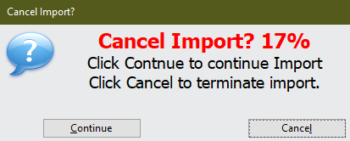

When the import is completed press the Close alt-c button to close the Importing Status window.
The import window will display the books that were imported and any errors.
- Press the View button alt-v – Open a detailed view of the book with errors, or F8 when cursor is in the title field. See Import Detail window below.
- Click Add or alt-a to add all books imported without errors to the database.
- If there are no more books on the import list the import Window will close, and the Audio Book Window is displayed. If errors exists the Import window will remain open.

Collection Window
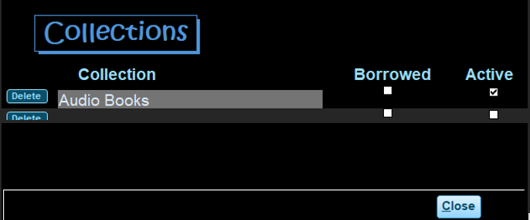
Collection Window Header – no controls
Collection Window Detail
Three controlls
- Delete button
- Collection name
- Active checkbox – If checked then the collection is shown in the Collection combo on the Audio Book and Import Windows. To hide a collection uncheck the Active checkbox.
Collection Window Footer – Close alt-c or F4.

Author, Genre, and Series Windows
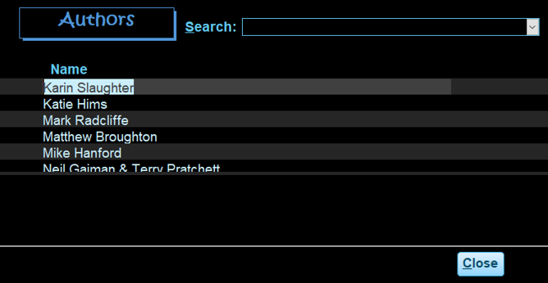
These three Windows are similar with the same controls and layout. They are for making corrections to Author, Series or Genre.
Author Window Header - Search combo box to quickly move to a particular Author.
Author Window Detail - Continuous list Author Name.
Author Window Footer – Close alt-c or F4.
Note: Author, Collection, Genre, or Series cannot be deleted if there are books associated with them.

Backup/Restore Window
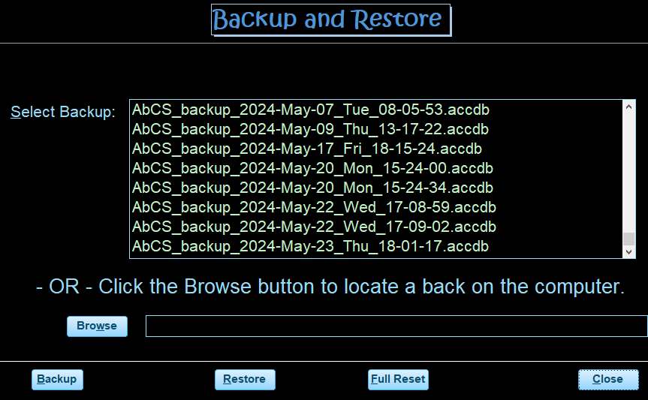
Backup/Restore Window Header – no controls

Backup/Restore Window – detail
- Listbox – list existing backups
- Browse button – to select a backup that is located somewhere other than the default backup folder
- text box – Display the name of the backup file to be restored.

Backup/Restore Window – Footer
Four buttons:
- Backup alt-b – creates a backup of the application in the default bacckup folder
- Resore alt-r – Restores the application from a selected backup
- Full Reset alt-f – Clears all data in the application.
- Close alt-c or F4 – Close the Backup/Restore window.

Backup files are names are: AbCS_backup_yyyy-mm-dd_ddd_hh-mm-ss
e.g. AbCS_backup_2024-May-17_Fri_18-15-24.

Import Errors Description
Error messages | Cause / tag issue
Author Blank | Blank tag for Album Artist and Artist tag
Author name in Title | Title contains author name (not always an error)
Author Name is 'Artist Album' | Album Artist and Artist tag are null
Author Name is 'Unknown Artist' | Unknown in Album Artist and Artist tag
Author Name Starts with | Author name begins with non-alphabetic character
Duplicate Author & Title | Duplicates are those records having the same Title, Author, Year and Collection
File not found | The folder/files being scanned have move – usually caused by USB drive being disconnected from the computer.
Read Error | Unable to read the file. Usually due to corrupted tags in the file.
Title Blank | Blank tag for Album is blank
Title in Author name | Book title appears in Author Tag

ID3Tags scanned during import:
Book Data Field | ID3Tag Source
Book Title | Album (13)
Author | Album Artist (237) if empty Artist (13)
Size in MB | TrackSize (1) in kb accumulated if multiple files.
Time in hours & minutes | Track Time (27) accumulated if multiple files.
Release year | Year (15)
Audio Quality | Bitrate (28) in kb
Genre | Genre (16)
Comments | Comments (240 accumulated if different in each file of a book. Scan for “read by”, etc.
Reader/narrator | Composer (243) sometimes contains the narrator/reader.

